Wrong For Each Other

The Smiths Falls Community Theatre’s next show is Norm Foster’s “Wrong For Each Other”. The show is being directed by Jeremy Dutton and will be performed in the intimate theatre arts room at the Smiths Falls Collegiate Institute. The dates of the show are Friday April 4th, Saturday April 5th, Sunday April 6th, Friday April 11th, Saturday April 12th, Sunday April 13th, Thursday April 17th, Friday April 18th and Saturday April 19th. Show times are 8 p.m. for all shows except the two Sunday shows, which are matinees that begin at 2 p.m. The show takes an hilarious and sometimes heart-breaking look at the ups and downs of a relationship between Norah and Rudy. The cast includes Rob Umpherson, Joanna McAuley, Raynee Doner-Hodge and Jamie Schoular. Tickets are $10.00 in advance and can be purchased in Smiths Falls at Special Greetings, Bham’s Kiosk, Smolkins Men’s Wear and in Perth at Royal LePage (Pauline Aunger). Tickets can also be purchased at the door for $12.00.

“The Last Spike”

Our final fund raising push continues. So far, people have donated over $30,000, which is a $16,000 increase since February. There will be a plaque in the lobby mezzanine recognizing all of our donors. Those who donate will get a tax receipt. Don’t forget our "garage sale" on Saturday 31st at the Station, so if anyone has articles to donate we would be happy to accept them. For more information, call Nancy Yunker at 613-283-7696 or mail donations to PO Box 846 Smiths Falls, K7A 4W6.

Volunteers Move the Project Forward!

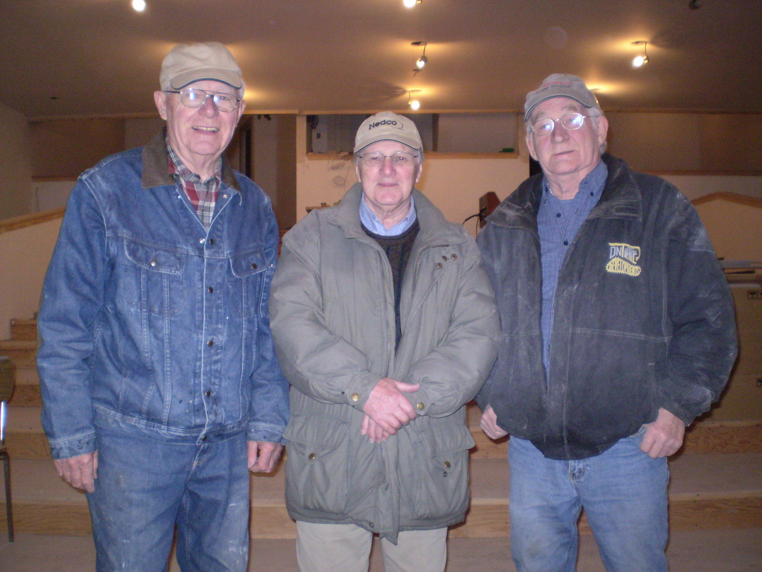

Thanks to the dedication of these three volunteers, the work to complete The Station Theatre continues to move ahead. Pictured above, from left to right, are Mo Guilbault, Pat Smith and Wayne Henwood. Mo is retired from IBM and has used his love of woodworking to complete much of the trim and the railings in the theatre. Pat has been the project manager from the very beginning and brings a wide range of skills and experiences to this project. His involvement in the project is key to the development and the eventual completion of our theatre. Wayne is retired from a local radio station and spent many years working with the National Film Board of Canada. He is our resident expert on sound and lighting. These men are at the station every Monday to Friday, first thing in the morning. Most recently, they have been mainly responsible for the work that has progressed in the backstage area. This has included the installation of the drywall for the dressing rooms and the sidewalls on the risers, the trim in the theatre and the wiring. We are tremendously indebted to their outstanding work.

